
Newsletter: Friday 13th March 2026
For more pictures of current and future events, please follow our school Instagram and Facebook pages: @StJosephsSLH

It is certainly a busy time for us at school; our landscaping team have been working hard to develop the St Joseph’s Garden of Peace – a space for reflection, quiet and prayer, an amazing world book day, preparations for a busy Book Fayre, our year 6 residential and the start of our reconciliation services in preparation for Lent.
The children have also been exceptionally focused on their key learning skills from some tricky maths to using and applying their phonics; it has been a hive of activity!

The internal work for the heating system has also started this week – a big well done and thank you to Year 3 for moving out of their classroom so maturely whilst this work was done.

As always there is lots of exciting and interesting things happening this term, please do the check the fortnightly ‘Looking Ahead’ dates at the end of the newsletter along with the website diary which is regularly updated here
Have a super weekend and for those of you celebrating – Happy Mother’s Day!
Mrs McBrown

Sunday 15th March – Seeing clearly
 | The Gospel for the 4th Sunday of Lent tells how Jesus heals a man who was born blind. The people around him do not believe it. They ask many questions and argue about what happened. The Pharisees are upset because Jesus healed on the Sabbath. But the man who was healed believes in Jesus and worships Him.  This Sunday helps us think about spiritual blindness. Some people saw the miracle but still did not believe. Others, like the blind man, could see the truth. Lent is a time to ask Jesus to help us see clearly. We can pray for faith and for open eyes to see God working in our lives.

Lord Jesus, You opened the eyes of the blind man and filled his darkness with light. Open my eyes too, that I may see Your truth, recognize Your presence in my life, and follow You with faith and gratitude. Heal the blindness in my heart, that I may walk always in Your light.
Amen

Y4 Class Liturgy
Last week, we enjoyed Year 4’s class liturgy who shared their learning and led us in prayer through Jesus’ time in the desert. Through symbolism and key readings year 4 shared their thoughts and demonstrated a huge growth in maturity and public speaking skills - well done Year 4! Thank you to Mr Stephens for preparing the children so beautifully.

St Joseph’s Garden of Peace
Rosie and the team have been hard at work in our outside spaces once again! The slice of land behind the Key Stage 2 classrooms has been transformed and is on its way to becoming a beautiful garden for the children to access.
Rosie and the team have removed the pond, making the area safe, levelled the ground and reseeded it with grass seed, cut back the trees, jet washed and repaired the external walls as well as installing benches, a cross and a smaller, safer water feature. Please do take a look when you come to collect the children - we can’t wait to see those first green shoots!
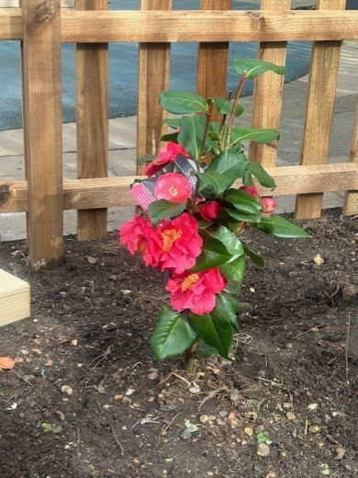 | 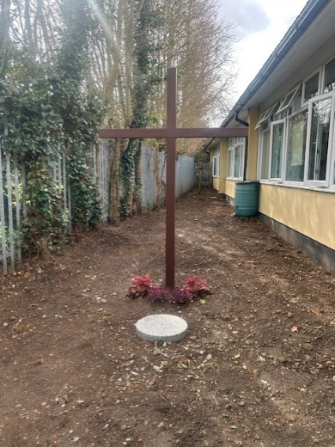 | 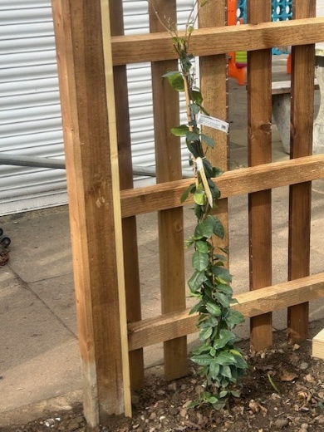
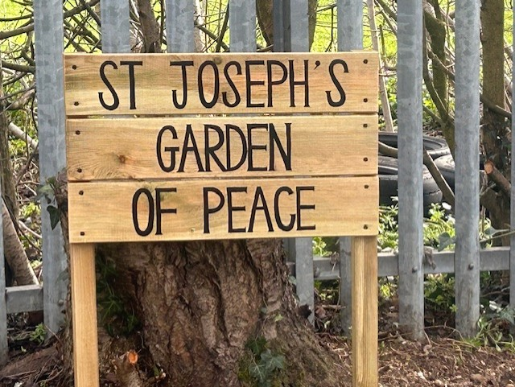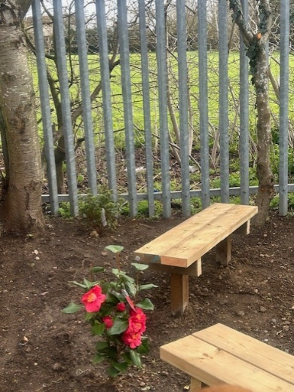

World Book Day

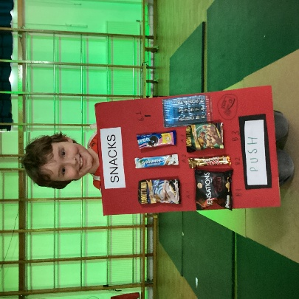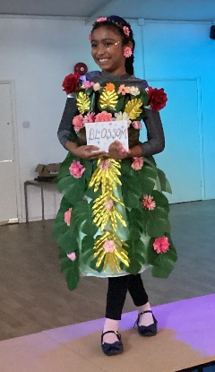 | Thank you to all who were able to attend the World Book Day parade and for the children’s super words and phrases costumes! We loved trying to guess them all. Please check out our Instagram page for some super photographs that were taken on the catwalk a little later in the day!  Each child brought home a World Book Day voucher; these do expire quite quickly so do try and spend it in your local bookshop!

Year 6 Residential – Stubbers
Year 6 have spent the last 3 days on residential at Stubbers Outdoor Adventure Centre. They have had a wonderful time climbing, taking part in water sports, team building and a whole host of other exciting activities.  Overall, the children have been a real credit to us all and their behaviour was commented upon by the instructors working with them. A huge thank you to Mrs Tapatau and Mr Lovell who have given up their time to take the children.  Please check out our Instagram page for some super photographs of the children’s adventures.  Stubbers also run lots of activity sessions through the school holidays – more details can be found on their website here. The Easter holidays will be here in the blink of an eye! | 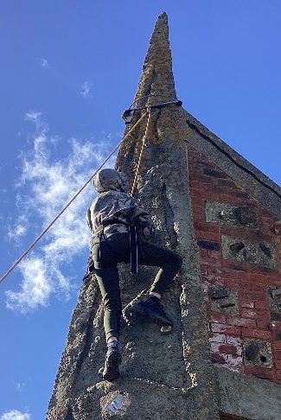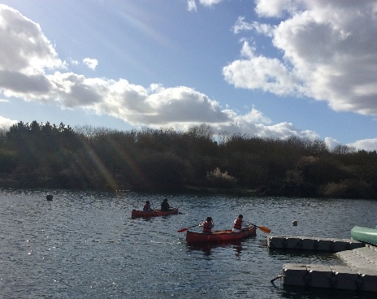

AdLent
Year 2 have done a super job so far in organising us for AdLent, they have collected all sorts of goodies which have been generously donated by our families which they will then pass on to Thurrock Foodbank. Not only is this amazing work for our local community but also supports the children in understanding the one of the three pillars of Lent – Almsgiving. A huge thank you to Year 2, Miss Torley, Miss Sinfield and Miss McLeod for organising the children so brilliantly and thank you to you all for all you have been able to share.

Uniform
The children’s school uniform is exceptionally smart – a huge thank you to you all for supporting this. Please may you ensure that your child’s hair accessories – bows, bands, clips and beads - are in school colours and that your child is wearing their school tie. Thank you. The full uniform list, which was created in consultation with parents last summer, can be found here if you are unsure.

Looking Ahead… Spring term
Week beg 16th March | Scholastic Book Fayre
Tuesday 17th March | Reconciliation in school. Children who have made their First Holy Communion are invited to join Fr. Anthony in school for Reconciliation.
Wednesday 18th March  2.45pm | Lent Stay and Pray – come and join the GIFT team to prepare yourself for Easter as part of our Lenten preparations
Thursday 19th March | Feast Day of St Joseph - please join us for Mass at 9.15am to celebrate.  This is a non-uniform day and we ask that the children wear something green as Joseph is often depicted wearing green.
Friday 20th March | Big Lent Walk – please see previous letter sent. Link to our Just Giving sponsor page here.
Tuesday 24th March  2.30pm | Y3 and Y4 Easter Production – Stations of the Cross
Wednesday 25th March 9.15am | Rock Steady Concert. Families of participants have been sent home tickets.
Thursday 27th March | Easter Egg Competition – further detail to follow
Friday 28th March | Final day of Spring term. Children to be collected at 3:15pm.

Please remember to check the school website here for further dates and details.

